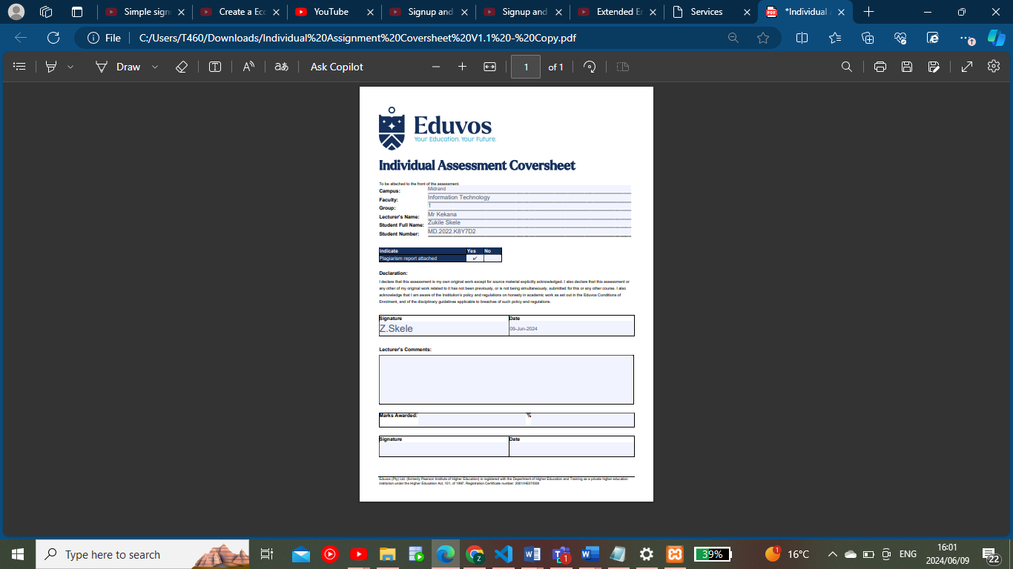

Table of Contents

**Introduction** 3

**Prototyping** 3

Prototype 1 3

Prototype 2 3

**Designing** 4

a) Class Responsibility Collaborator Cards 4

b) Enhanced Entity Relationship Diagram 5

c) Context Diagram 5

d) Data Flow Diagram 6

e) Use Case Diagram 7

f) Database Design 7

**Coding** 8

**a)** **Screenshots** 8

Sign Up Page 8

Sign Up Success page 8

Login Page 9

9

Home Page 10

AboutUs Page 11

Services Page 13

ContactUs 14

Cart 15

**b)** **Sample PHP codes** 15

Functions.php: 15

Database.php 16

Login.php 17

**c)** **Sample HTML code** 17

Home.html 17

about.html 19

Services.html 20

**d)** **Sample MySQL Table Screenshots** 23

Users database table 23

Services database table 23

**Conclusion** 24

**Sign-Off** 24

# **Introduction**

Igugulethu Consulting, a prominent company that provides engineering solutions to a variety of industries, has successfully completed its robust, database-driven e-commerce web application. Igugulethu Consulting, founded in 2019, has established itself as a market leader in providing high-quality engineering services such as design, construction, and project management. The newly established e-commerce platform demonstrates the company's commitment to innovation, efficiency, and customer pleasure, distinguishing it in the competitive technical field. In response to the growing reliance on technology and the internet, this project was critical for streamlining business operations and improving the client experience, marking an important turning point in Igugulethu Consulting's growth and adaptability.

# **Prototyping**

### Prototype 1

### Prototype 2

# **Designing**

## Class Responsibility Collaborator Cards

## Enhanced Entity Relationship Diagram

## Context Diagram

## Data Flow Diagram

## Use Case Diagram

## Database Design

# **Coding**

## **Screenshots**

### Sign Up Page

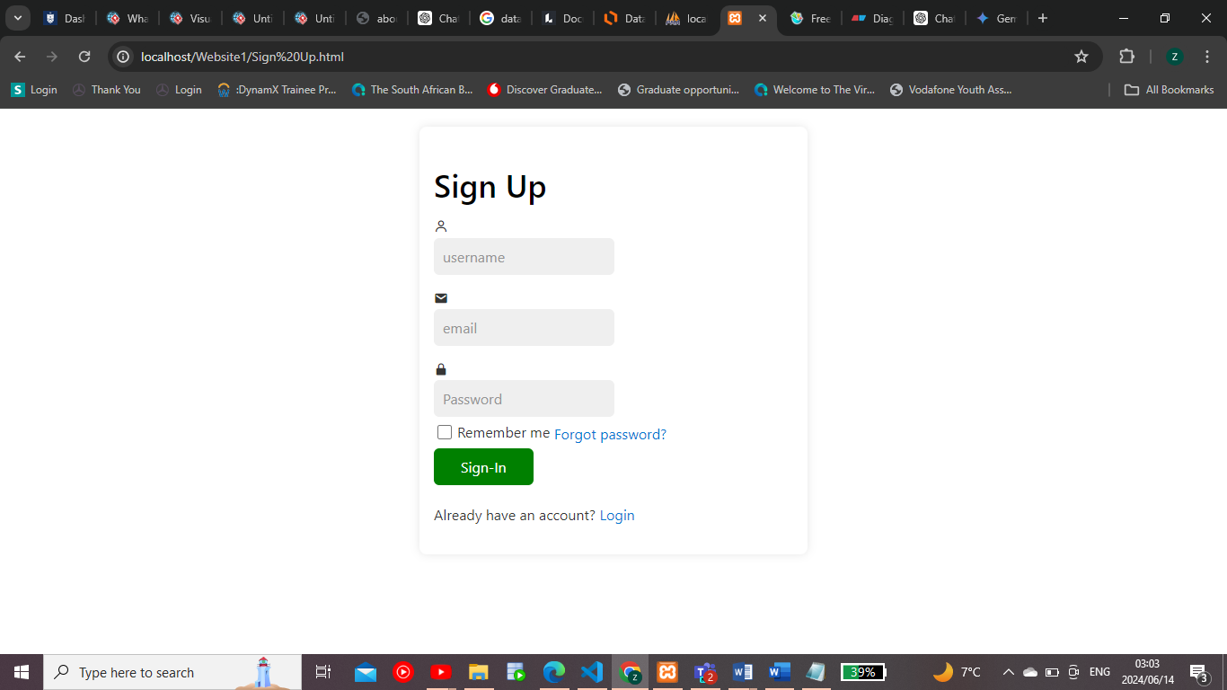

### A screenshot of a computer Description automatically generatedSign Up Success page

### Login Page

### 

### A computer screen shot of a website Description automatically generatedHome Page

### A screenshot of a computer Description automatically generatedAboutUs Page

### Services Page

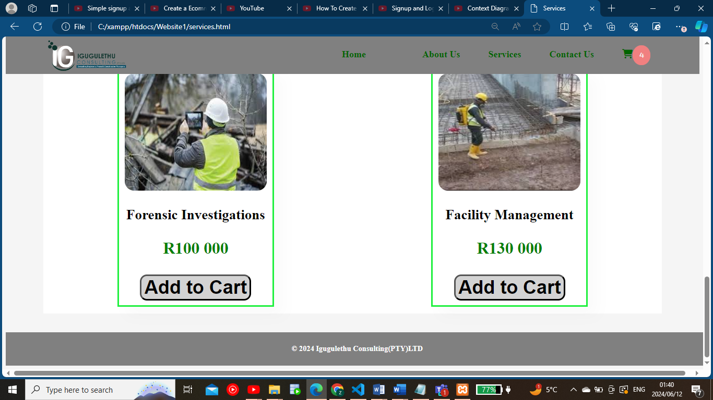

### ContactUs

### Cart

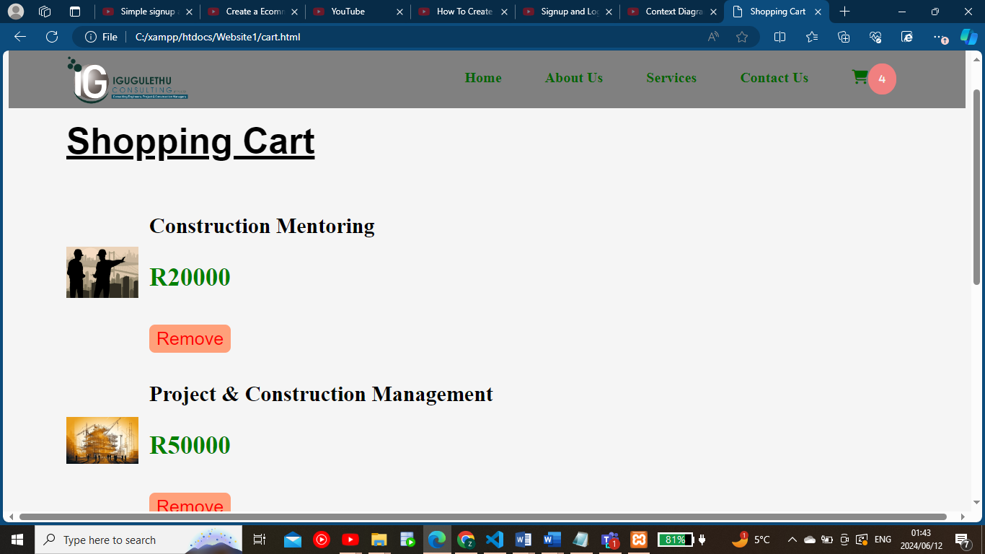

### **Sample PHP codes**

### Functions.php:

<?php

if(empty($_POST["username"])) {

    die ("Username is required");

}

if (!filter_var($_POST["email"], FILTER_VALIDATE_EMAIL)) {

    die ("Valid email is required.");

}

if(strlen($_POST["password"]) <8 ) {

    die ("Password requires at least 8 characters.");

}

if(!preg_match("/[a-z]/i", $_POST["password"])) {

    die ("Password must contain at least 1 letter.");

}

if(!preg_match("/[1-9]/", $_POST["password"])) {

    die ("Password must contain at least 1 number.");

}

$password_hash = password_hash($_POST["password"], PASSWORD_DEFAULT );

$mysqli= require __DIR__ ."/database.php";

$sql= "INSERT INTO users (Username, email, Password)

        VALUES (?, ?, ?)";

    $stmt = $mysqli->stmt_init();

    if (!$stmt->prepare($sql)) {

        die ("SQL error: " . $mysqli->error);

    }

$stmt->bind_param("sss",

                    $_POST["username"],

                    $_POST["email"],

                    $password_hash);

$stmt->execute();

header("Location: Signup Success.html");

exit

?>

### Database.php

<?php

$host="localhost:3307";

$username="root";

$password="";

$dbname="login_db";

$mysqli = new mysqli($host, $username, $password, $dbname);

if($mysqli->connect_errno) {

    die ("Connection error ". $mysqli->connect_error);

}

return($mysqli);

### Login.php

 <?php

        if(isset($_POST['login'])){

            $email= $_POST['email'];

            $password= $_POST['password'];

            require_once "database.php";

            $sql= "SELECT *FROM users where email='$email'";

            $result = mysqli_query($mysqli, $sql);

            $user= mysqli_fetch_array($result, MYSQLI_ASSOC);

            if($user){

                if(password_verify($password, $user['Password']));

                header("Location:home.html");

                die();

            }

            else {

                echo "<div class='alert>Password does not match</div>";

            }

        }

    ?>

### **Sample HTML code**

### Home.html

<!DOCTYPE html>

<html>

<head>

<title>Home</title>

<link rel = "stylesheet" type = "text/css" href = "services.css">

<link rel="stylesheet" href="https://cdnjs.cloudflare.com/ajax/libs/font-awesome/6.5.2/css/all.min.css">

</head>

      <div class = "menu_bar">

        <img class="logo" = img src = "IGUGULETHU LOGO.png">

            <ul>

                    <li><a href="Home.html">Home </a></li></li>

                    <li><a href="about.html">About Us</a></li>

                    <li><a href="services.html">Services </a></li>

                    <li><a href="contact.html">Contact Us</a></li>

                    <li><a href="cart.html"><i class="fa-solid fa-cart-shopping"><span>0</span></i></a></li>

            </ul>

      </div>

    <body>

        <br>

    <div class="hero">

        <h1>Consulting Engineers,<br> Project and <br>Construction Managers</h1>

        <button><a href=".section1" class="services"> See More </a></button>

    </div>

   <section id="services" class="section1">

        <h1>Featured Services</h1>

        <div class="service_container">

            <div class="serv">

                <img src="asset.png" alt="">

                <div class="description">

                    <h3>Asset Management</h3>

                </div>

                <p>R15 000</p>

                <button onclick="addToCart('Asset Management', 15000)">Add to Cart</button>

            </div>

                <div class="serv">

                    <img src="mentor.png" alt="">

                    <div class="description">

                        <h3>Construction Mentoring</h3>

                    </div>

                    <p>R20 000</p>

                    <button onclick="addToCart('Construction Mentoring', 20000)">Add to Cart</button>

                </div>

                    <div class="serv">

                        <img src="img1.png" alt="">

                        <div class="description">

                            <h3>Project & Construction Management</h3>

                        </div>

                        <p>R 50 000</p>

                        <button onclick="addToCart('Project & Construction Management', 50000)">Add to Cart</button>

                    </div>

                </div>

                    <button><a href="services.html"> More Services </a></button>

   </section>

   <section id="banner" class="section2">

        <h1>More about <br><span>  Igugulethu Consulting</span></h1>

        <button><a href="about.html">Explore More </a></button>

   </section>

    <main>

    </main>

    <script src="scripts.js"></script>

</body>

<footer>

    <p> © 2024 Igugulethu Consulting(PTY)LTD </p>

</footer>

<script src="services.js"></script>

<script src="cart.js"></script>

</html>

### about.html

<!DOCTYPE html>

<html>

<head>

<title>About Us</title>

<link rel = "stylesheet" type = "text/css" href = "about.css">

<link rel="stylesheet" href="https://cdnjs.cloudflare.com/ajax/libs/font-awesome/6.5.2/css/all.min.css">

</head>

<body>

    <div class = "menu_bar">

        <img class="logo" = img src = "IGUGULETHU LOGO.png">

            <ul>

                    <li><a href="Home.html">Home </a><li>

                    <li><a href="about.html">About Us</a></li>

                    <li><a href="services.html">Services</a></li>

                    <li><a href="contact.html">Contact Us</a></li>

                    <li><a href="cart.html"><i class="fa-solid fa-cart-shopping"><span>0</span></i></a></li>

            </ul>

      </div>

    <main>

     <br></br>

     <div class="photo">

        <h1>About Us</h1>

     <img src="photo1.png">

    </div>

     <br></br>

     <div class="content">

     <a></a><p style="border: 4px solid forestgreen;"> Igugulethu Consultung was founded in 2019 by Thamsanqa Skele after being a part of the engineering industry <br> for 30 years and being involved with Consulting Civil Engineering, Project and Construction Management. Igugulethu Consulting <br>is in association with some of the leading players within the industry. We presently have 10 (ten) technical staff members as well as<br> 2 (two) administrators.</p>

    </div>

    <div class="about">

        <img src="vision.png" width="350px">

        <img src="mission.png" width="350px">

    </div>

    </main>

</body>

<br></br>

<footer>

    <p>© 2024 Igugulethu Consulting(PTY)LTD</p>

</footer>

<script src="cart.js"></script>

</html>

### Services.html

<!DOCTYPE html>

<html>

<head>

<title>Services</title>

<link rel = "stylesheet" type = "text/css" href = "services.css">

<link rel="stylesheet" href="https://cdnjs.cloudflare.com/ajax/libs/font-awesome/6.5.2/css/all.min.css">

</head>

<body>

    <div class = "menu_bar">

        <img class="logo" = img src = "IGUGULETHU LOGO.png">

            <ul>

                    <li><a href="Home.html">Home <a><li>

                    <li><a href="about.html">About Us</a></li>

                    <li><a href="services.html">Services</a></li>

                    <li><a href="contact.html">Contact Us</a></li>

                    <li><a href="cart.html"><i class="fa-solid fa-cart-shopping"><span id="cart-count">0</span></i></a></li>

            </ul>

      </div>

      <section id="services" class="section1">

        <h1> Services</h1>

        <div class="service_container">

            <div class="serv">

                <img src="asset.png" alt="">

                <div class="description">

                    <h3>Asset Management</h3>

                </div>

                <p>R15 000</p>

                <button onclick="addToCart('Asset Management', 15000, 'asset.png')">Add to Cart</button>

            </div>

                <div class="serv">

                    <img src="mentor.png" alt="">

                    <div class="description">

                        <h3>Construction Mentoring</h3>

                    </div>

                    <p>R20 000</p>

                    <button onclick="addToCart('Construction Mentoring', 20000, 'mentor.png')">Add to Cart</button>

                </div>

                <div class="serv">

                    <img src="img1.png" alt="">

                    <div class="description">

                        <h3>Project & Construction Management</h3>

                    </div>

                    <p>R 50 000</p>

                    <button onclick="addToCart('Project & Construction Management', 50000, 'img1.png')">Add to Cart</button>

                </div>

                </div>

            </section>

    <main>

    </main>

</body>

<footer>

    <p>© 2024 Igugulethu Consulting(PTY)LTD</p>

</footer>

<script src="services.js"></script>

</html>

### Sample JavaScript code

### services.js

function addToCart(name, price, image) {

    let cart = JSON.parse(localStorage.getItem('cart')) || [];

    cart.push({ name, price, image });

    localStorage.setItem('cart', JSON.stringify(cart));

    updateCartCount();

}

function updateCartCount() {

    const cart = JSON.parse(localStorage.getItem('cart')) || [];

    document.getElementById('cart-count').innerText = cart.length;

}

document.addEventListener('DOMContentLoaded', updateCartCount);

### cart.js

### **Sample MySQL Table Screenshots**

### Users database table

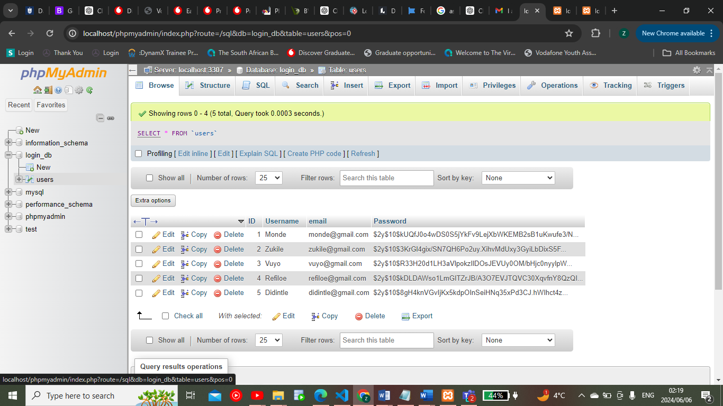

### Services database table

# **Conclusion**

In conclusion,

# **Sign-Off**

|  |  |  |  |
| --- | --- | --- | --- |
| Igugulethu Consulting |  |  | Zukile Skele |
| Project Client  Date: 16 May 2024 |  |  | Project Manager  Date: 06 June 2024 |